A systematic machince learning approach in fitness platform –Fitcheck
Objective:
The objective of the FitCheck fitness platform is to develop a systematic machine learning–based approach that analyzes user fitness data—such as physical activity, body metrics, workout performance, and lifestyle patterns—to provide personalized fitness assessments and recommendations. The system aims to accurately evaluate fitness levels, track progress over time, predict health and performance trends, and suggest customized workout plans and wellness guidance, thereby improving user engagement, fitness outcomes, and overall health awareness through data-driven decision-making.
Abstract:
FitCheck is a smart fitness platform that adopts a systematic machine learning approach to deliver personalized fitness assessment and recommendations. The system collects and analyzes user-specific data such as age, gender, body measurements, activity levels, workout history, and lifestyle habits to evaluate individual fitness status. Machine learning models are applied to identify patterns, predict fitness trends, and generate customized workout and wellness suggestions. Unlike traditional fitness applications that rely on generic plans, FitCheck adapts dynamically to user progress and changing fitness goals. The platform aims to enhance accuracy in fitness evaluation, improve user motivation, and support healthier lifestyle decisions through intelligent, data-driven insights.
Introduction:
In recent years, the growing awareness of health and fitness has led to an increased demand for digital fitness platforms that support individuals in maintaining an active and healthy lifestyle. Traditional fitness applications often provide generalized workout plans and static recommendations that fail to consider individual differences such as body composition, fitness level, and personal goals. As a result, users may experience ineffective training outcomes or lose motivation over time.
Machine learning offers a powerful solution by enabling systems to analyze large volumes of fitness-related data and generate personalized insights. By learning from user behavior, performance trends, and physiological parameters, machine learning models can adapt fitness recommendations to meet individual needs. The FitCheck platform leverages a systematic machine learning approach to assess fitness levels, monitor progress, and provide tailored workout and wellness guidance. This intelligent personalization helps users make informed decisions, improves engagement, and supports sustainable health and fitness improvements.
Problem Statement:
Many existing fitness platforms rely on generic workout routines and predefined rules that do not account for individual differences in fitness levels, body composition, lifestyle habits, and personal goals. This lack of personalization often leads to ineffective training, poor user engagement, and inconsistent fitness outcomes. Additionally, users find it difficult to accurately track their progress and understand how their daily activities and habits impact overall fitness. There is a need for an intelligent fitness platform that can systematically analyze user data, adapt to changing fitness patterns, and provide personalized, data-driven fitness assessments and recommendations. The FitCheck platform addresses this problem by applying machine learning techniques to deliver accurate fitness evaluation, progress prediction, and customized fitness guidance.
Existing System:
In the current fitness ecosystem, users rely primarily on traditional fitness applications, wearable trackers, and online workout guides to manage their health and exercise routines. These systems typically offer generic workout plans, basic activity tracking, and manual progress logs. Users are often required to enter their personal data and choose from predefined workout programs without receiving tailored guidance based on their unique fitness profile.
Many existing platforms provide static feedback and simple metrics like step counts, calories burned, or workout completion status. While some apps integrate basic analytics, they rarely leverage advanced machine learning to interpret patterns, predict fitness trends, or customize recommendations based on individual performance and lifestyle data. Consequently, users face challenges in achieving optimal results due to a lack of personalized insights and adaptive coaching.
Disadvantages:
- Provides generic workout plans that do not adapt to individual fitness levels, body conditions, or goals.
- Lacks advanced machine learning techniques for accurate fitness assessment and prediction.
- Offers static recommendations that do not change based on user progress or performance trends.
- Limited integration of diverse fitness data such as lifestyle habits, sleep patterns, and long-term activity history.
- Inadequate progress tracking and lack of predictive insights reduce user motivation.
Proposed System:
The proposed system, FitCheck, is an intelligent fitness platform that utilizes a systematic machine learning approach to deliver personalized fitness assessment and recommendations. The system collects comprehensive user data, including physical attributes, activity levels, workout history, and lifestyle patterns, and processes this data using trained machine learning models. These models analyze patterns, classify fitness levels, and predict future performance trends.
FitCheck dynamically adapts workout plans and fitness guidance based on user progress and changing goals, ensuring personalized and effective recommendations. The platform integrates continuous learning, allowing the system to improve accuracy over time as more user data is collected. By providing real-time insights, progress visualization, and customized coaching, the proposed system overcomes the limitations of traditional fitness applications and enhances user engagement, motivation, and overall fitness outcomes.
Advantages:
- Provides personalized fitness assessments and workout recommendations based on individual user data.
- Uses machine learning to adapt plans dynamically according to user progress and performance.
- Improves accuracy in fitness evaluation through data-driven analysis rather than generic rules.
- Enables predictive insights to help users understand future fitness trends and outcomes.
- Enhances user engagement and motivation with customized goals and real-time feedback.
- Integrates multiple fitness parameters such as activity, lifestyle habits, and historical data.
System architecture
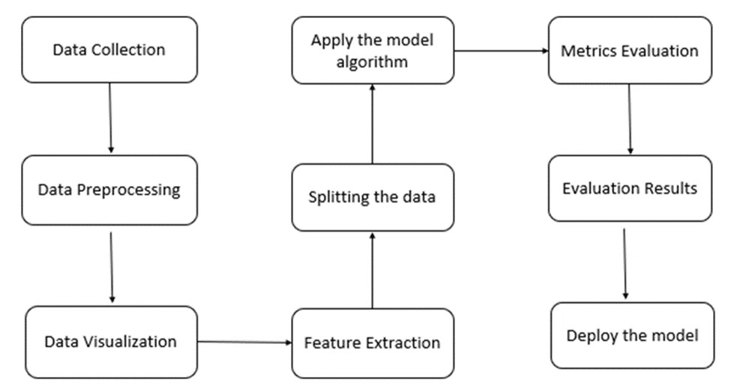
HARDWARE REQUIREMENTS
- Processor (CPU) Intel Core i5/i7 or equivalent, 2.5 GHz
- RAM Minimum 8 GB
- Storage At least 500 GB HDD or SSD
SOFTWARE REQUIREMENTS
- Operating System Windows 10/11,
- Programming Languages Python 3.x
- Web Framework Flask
- Tools jupyter notebook
Conclusion:
The FitCheck fitness platform demonstrates the effectiveness of a systematic machine learning approach in transforming traditional fitness applications into intelligent, personalized systems. By analyzing user-specific fitness data and adapting recommendations based on individual progress, FitCheck overcomes the limitations of generic workout plans and static feedback. The platform enhances accuracy in fitness assessment, improves user engagement, and supports informed health and wellness decisions. Overall, FitCheck provides a scalable and data-driven solution that promotes sustainable fitness improvement and a healthier lifestyle through intelligent automation and personalized guidance.
References
- Chen, Q., & Lee, S. (2021). A Machine Learning Approach to Predict Customer Usage of a Home Workout Platform. Applied Sciences, 11(21), 9927. https://doi.org/10.3390/app11219927
- Juan Chen & Yan Wang. (2025). Personalized fitness recommendations using machine learning for optimized national health strategy. Scientific Reports.
- IoT Based Health Monitoring with Diet, Exercise and Calories Recommendation Using Machine Learning. (2025). Human-Centric Intelligent Systems.
- Abdifatah Ahmed Gedi et al. (2025). Personalized Gym Recommendation System Using Machine Learning. International Journal of Engineering Trends and Technology, 73(4), 249–257.
- Jubair, H., & Mehenaz, M. (2025). Utilizing machine learning algorithms for personalized workout recommendations and monitoring: A systematic review on smartwatch-assisted exercise prescription. Digital Health.
- Chiam, J., Lim, A., Nott, C., et al. (2024). Co-Pilot for Health: Personalized Algorithmic AI Nudging to Improve Health Outcomes. arXiv:2401.10816.
- Liu, X., Gao, B., Suleiman, B., et al. (2022). P3FitRec: Privacy-Preserving Personalized Fitness Recommender System Using Deep Learning. arXiv:2203.12200.
- Ashley, K. (2020). Applied Machine Learning for Health and Fitness: A Practical Guide (Springer).

